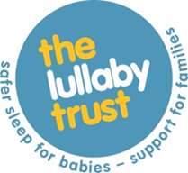

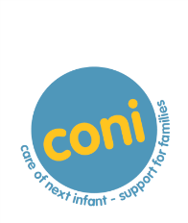

co-ordinator notification of non-participation
It is important for us to record as accurately as possible the number of families who decline CONI, or who use CONI but do not wish their details to be sent to the CONI Team.
Please use this form to notify us of any families known to you who are eligible to participate on CONI and decide against using the programme or who enrol on CONI but decline consent for details to be sent to the CONI Team.
Local Co-ordinator ID*

If you don't remember your ID you can email the CONI team at coni@lullabytrust.org.uk
Employer:

Baby's/Parent’s details
Year baby due/born *

What is the mother's postcode? (first part and first number e.g. EX39 3; HD1 4; W9 3; SG5 3)*

0 of 5 max characters

Reason for enrolment on CONI:
Previous sudden unexpected infant death of child of the: mother / father / both parents
Close relative died of SIDS
'Other' baby death
Apparent Life-threatening Event (ALTE)
Other, please specify:

Family are enrolled but do not wish information to be shared with the Lullaby Trust*
Yes

Parents have decided against using CONI*
Yes
For following reason:

Date*

Please send by email to: coni@lullabytrust.org.uk or post to the CONI Team, The Lullaby Trust, CAN Mezzanine – Borough, 7-14 Great Dover St, London SE1 4YR
You can change the way you hear from The Lullaby Trust at any time by emailing: office@lullabytrust.org.uk or calling 020 7802 3200. Please also see our privacy policy on our website for how we collect, use and look after your information.

