Dear CONI coordinators

Good news!

The distributers Nimans have given the Lullaby Trust 300 free SNUZA Hero MD monitors for use by families who are on the CONI programme.

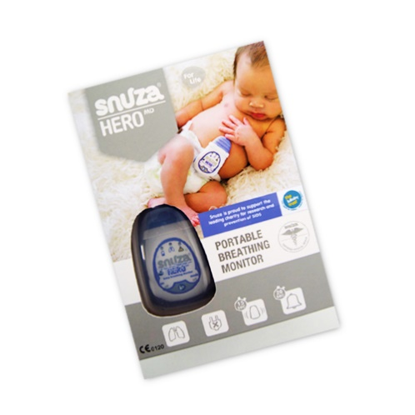
These monitors are a gift to the family from the distributer of SNUZA Hero MD not the Lullaby Trust or your employers. As the CONI coordinator you will nominate the family and the SNUZA Hero MD will be sent directly to them. Nominations will be received by the CONI team and the monitor will be allocated on a single use, named baby basis. Therefore, it can’t be ordered to have just in case needed.

Which families may benefit from a SNUZA hero MD?

- The family/baby are eligible for CONI programme support (in line with local CONI guidelines)
- Previously been on CONI and have lost/not returned a monitor
- Coordinator assesses that SNUZA will be easier/more appropriate for family to use than other monitors available to lend them e.g. toddlers around, concerns about safety, sensors being pulled or getting tangled.
- Monitor is needed urgently due to late referral, baby is already born, no other monitors available.
- Family expressed preference for a SNUZA Hero MD, after coordinator has explained local monitor options (if appropriate)
- Baby is over 6 months old and a mattress monitor is not available

Coordinators responsibility

- Discuss this arrangement with your manager who should seek local legal/governance advice before you start to talk with families
- Coordinator assesses family suitability for SNUZA Hero MD
- Explain to family the terms of them receiving a monitor. This can be found in ‘What the family needs to know’ section below
- CONI coordinators go to Lullaby Trust website https://www.lullabytrust.org.uk/professionals/care-of-next-infant/ to complete and submit the Nomination Form
- It is the coordinator’s responsibility to check the monitor has arrived with the family and to notify CONI team coni@lullabytrust.org.uk if it hasn’t arrived
- Need to discuss limitations of monitors – updated information can be found in the Monitor Information for Coordinators on the Lullaby Trust website
- Need to discuss what to do if the alarm goes off, this includes a plan and Basic Life Support instruction/ helping your baby until help arrives
- Need parents/s verbal consent to send name, address and telephone number to Lullaby Trust – it will not be used for any other reason.

What the family needs to know

- Explain to family that it is a gift from the distributors (not the health visiting service or the Lullaby Trust)
- Each monitor is given on the understanding that it is on single use for their baby only; named baby basis
- Family are responsible for the monitor and keep it i.e. do not return it to Lullaby Trust or coordinator/HV
- Will be sent directly to their home (need their home address but it will not be used for anything else)
- It takes approximately 5 working days from request. Unfortunately, it does not fit through a standard letter box so instructions about a safe place to leave it, if not at home, is required
- If the monitor is lost/broken they may be given another sort of monitor but the offer of a SNUZA Hero MD cannot be repeated
- Any complaints or problems to contact their coordinator/HV
- An additional Lullaby Trust /CONI appropriate information leaflet is contained within the monitor box
- Ask parent/s if they will be willing to give feedback (either telephone interview or online) when they are nominated for the monitor

Lullaby Trust CONI team responsibility

- Receive nomination
- Order and despatch to family
- Inform coordinator by email that monitor has been sent to family
- Respond and follow up emails regarding non-delivery and keep coordinator updated
- Keep nominations and feedback documents, securely and in line with GDPR
- Advise and support CONI coordinators in a time sensitive way

I hope that you find this information useful but contact us at coni@lullabytrust.co.uk if you require further information.

Jo & Stella
National CONI coordinators

