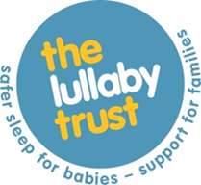

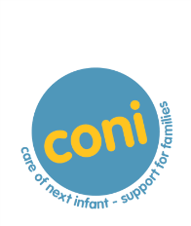
co-ordinator notification of BABY DEATH
It is essential that the CONI Team is notified immediately of the death of a baby enrolled on the programme. Please use this form to notify us of a baby death and send by email to: coni@lullabytrust.org.uk
If anyone involved with this baby’s death would like bereavement support please contact: 0808 080 26868.

Where the death presents suddenly the CONI Steering Group will normally offer expert advice to the local professionals involved. Please contact: coni@lullabytrust.org.uk
Local Co-ordinator ID* (If you don't remember your ID you can email the CONI Team at: coni@lullabytrust.org.uk)

Employer:

Baby's/Parent’s details
Baby’s date of birth *

Baby’s date of death *

Where does the mother live?*
County:

Mother's postcode (first part and first number e.g. EX39 3; HD1 4; W9 3; SG5 3)*

0 of 5 max characters
Date*

Please send by email to: coni@lullabytrust.org.uk
You can change the way you hear from The Lullaby Trust at any time by emailing: office@lullabytrust.org.uk or calling 020 7802 3200. Please also see our privacy policy on our website for how we collect, use and look after your information.

